Mathematics and multimodal literacy: A Systemic Functional perspective

Y.J. Doran

Australian Catholic University

- Mathematics and multimodal literacy

Mathematics and language are often counterposed in education. Numeracy is often distinguished from literacy; subjects such as English with a focus on literature, reading and writing, is often positioned on the opposite end of the curriculum to subjects such as mathematics oriented to problem-solving, numerical calculation and algebraic manipulation; and in chats with or about students we often hear that some are more a ‘mathematics-student’ rather than an ‘English-student’ or vice versa. On the other hand, mathematics and language are also sometimes positioned together. In many curricula, literacy and numeracy are positioned at the core, with regular public discussion about numeracy and literacy standards in whatever country it occurs; similarly subjects such as Mathematics and English are often compulsory subjects in much of schooling. No matter how mathematics and language are positioned in schooling, in this chapter we will see they interact deeply in schooling in ways that are often not acknowledged but must be understood if we are to develop rich multimodal literacy programs that can support students’ disciplinary learning across the curriculum.

This chapter focuses on the multimodal nature of mathematics education, specifically focusing on mathematical symbolism and language. Before beginning it is useful to make a distinction between mathematics education and mathematics in education. By mathematics education, I mean the teaching of mathematics as a subject. Mathematics education, like mathematics in general, is inherently multimodal, combining a wide range of mathematical symbolisms with a range of uses of language, a diverse set of diagrams, graphs and other images, and digital artefacts (O’Halloran 2005), across both face-to-face classroom teaching and written textbooks and assessments. By contrast, by mathematics in education, I refer to mathematical symbolism (e.g. F = ma) as used both in mathematics as a subject, but also in a many other subjects in the sciences, social sciences and the humanities. From this perspective mathematics in education is not limited to any particular subject per se but is drawn upon as needed in different subjects at different levels for different purposes.

Understanding both mathematics education and mathematics in education is vital for understanding mathematics as a multimodal phenomenon and for supporting the development of disciplinary literacy. Such an understanding also helps us connect multimodal literacy with conceptions of numeracy that go beyond a ‘narrow’ interpretation as a ‘facility with numbers and computation’ (Goos et al. 2019: 1). As one recent textbook for trainee teachers on teaching numeracy across the curriculum describes, numeracy involves ‘attention to real-life contexts; applications of mathematical knowledge; use of physical, representational and digital tools… promotion of positive dispositions toward the use of mathematics to solve real-life problems; [and] a critical orientation’ (Goos et al. 2019: 58; italics in original). This definition shows significant overlap multimodal literacy concerns in its critical orientation to different representational tools and contexts. Under this view, numeracy involves not just a focus on numbers, but also the ability to understand ‘verbal arguments’ and ‘visual representation or quantitative or spatial information such as graphs, diagrams and maps’ (ibid. 15). Although numeracy is not the focus of this chapter this definition highlights that the issues discussed below are not just relevant for mathematics education, nor even mathematics in education, but also for disciplinary knowledge in general.

The following sections will consider language and mathematical symbolism in both mathematics education and in other subjects that use mathematics. It will first focus on language in mathematics education, considering how language builds toward the use of mathematical symbolism and interacts with it. The chapter will then focus on mathematical symbolism itself, considering its use beyond mathematics education. Again, the focus on mathematical symbolism will be on its interaction with other resources such as language. When focusing on each resource, therefore, this chapter will take a multimodal view, in terms of how each resource works in relation to the other.

- Mathematics Education

As students move through mathematics education, they must learn to read and write an increasingly wide range of semiotic resources; and they must learn from reading and writing these resources. The multimodal nature of mathematics is illustrated in Figure 1, which shows a question from a final-year secondary school mathematics exam. This figure shows a multiple choice question that brings together technical language (e.g. the lengths of the interval, a positive number, point and line), with a cartesian graph showing a line (the horizontal line connecting P and Q) intersecting a parabola (the curved line labelled y = x²), with two distinct symbolic formalisms: elementary algebra (e.g. y = x², $y=\frac{x^{2}}{a^{2}}$) and geometric symbolism that describes the lines (PQ, ST).

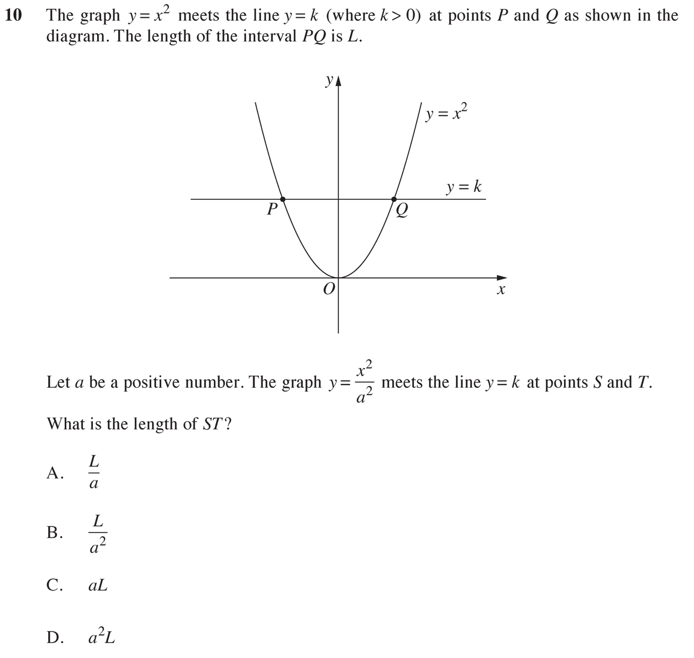

Figure 1 Mathematics Exam question (NSW Education Standards Authority 2023a: 8)

The fact that this one multiple choice question brings together four distinct and highly technical semiotic resources illustrates why mathematics can be considered, in some sense, the multimodal discipline par excellence. As a discipline it is almost entirely oriented to reading, writing, reasoning and problem solving across semiotic modes – symbolic, imagic and linguistic – with all being highly technical (O’Halloran 2005). As Lemke (2003) notes, mathematical symbolism can be seen as being ‘in the middle’ between language and image – bridging what he calls the ‘typological’ orientation of language that chunks meanings into discrete types and the ‘topological’ orientation of images that focus on continuous gradation. It is this combination of an overriding orientation to multimodality and technicality that perhaps accounts for why whole-school approaches to literacy that focus on language often struggle to meaningfully incorporate mathematics as a subject (Veel 1999).

- Language in Mathematics Education

In the multimodal discipline of mathematics, language plays a crucial role across pedagogy and assessment. Indeed, for students to succeed in mathematics, it is vital that they be supported in learning its technical register (Halliday 1978). There has been a long history of functional linguistic literacy work focusing on the language of mathematics (e.g. Halliday 1978, Veel 1999, Schleppegrell 2007, O’Halloran 2015, Accurso, Gebhard & Purington 2017). This work has highlighted, among other things, the range of linguistic genres occurring in mathematics (Marks & Mousley 1990; Rose 2021) and the grammatical and discourse semantic patterns that encode mathematical knowledge (Veel 1999). In this section, we will focus first on the written language of mathematics and then on the spoken language of mathematics classrooms. However as we will see, despite these sections focusing on language, every instance necessarily implicates other resources such as mathematical symbolism or images. This is either by virtue of language presenting a preliminary step toward mathematical symbols ontogenetically or logogenetically or language being used to explain the mathematical processes involved in manipulating mathematical symbols or interpreting images (O’Halloran 2015).

When thinking of the language of mathematics, we usually think of written language that includes dense statements filled with technicality:

Using simplexes one can compose more complex objects and figures. Let a set X of points of a Euclidean space (or, more generally, the so-called “topological space”) be represented as a union of a finite or countable number of curvilinear simplexes of dimensions from zero to a certain n. (Fomenko 1990: 8)

But as Veel (1999: 187) points out, in mathematics classrooms there is in fact ‘a distinctive division of ‘semiotic labour’ between the spoken and written modes.’ The written mode is oriented toward visual and symbolic resources when on the blackboard, white board or smartboard, and is joined in textbooks by highly technical language such as that above. By contrast, the spoken mode provides ongoing commentary that links the symbolic with the visual and with students’ more everyday knowledge. Veel in fact goes as far as to suggest that mathematics relies ‘extraordinarily on spoken language’ when compared to other subjects. Understanding the language of mathematics thus involves understanding both these orientations of language.

3.1 Written Language in Mathematics Education

Beginning first with written language in mathematics, Veel notes several key features of mathematical language that help construe its technical knowledge. We will focus on two here: technical lexis and grammatical metaphor.

As illustrated by the excerpt above, technical lexis is pervasive in mathematics. This excerpt alone includes examples such as simplex, set, Euclidean space, union, curvilinear etc. Mathematical technicality can either be unique terms specific to mathematics and related areas (e.g. curvilinear, Euclidean) or they can be re-encodings of non-technical vocabulary (e.g. set, point, union) (Halliday 1978).

Like all scientific registers, mathematical technicality tends to have interlocking definitions. Using Halliday’s (1989) example as an illustration, the geometric terms circle, centre, radius, diameter and circumference are all co-defining in some sense: a circle is a curve where every point on it is at the same distance, called the radius, from its centre; a diameter is defined as twice the radius; and the circumference is the length of the circle. Technical terms such as these are often brought together into technical taxonomies (Wignell et al. 1989). In the example above for instance Euclidean space is a type of space distinguished from, say, elliptical space as used for the geometry of spheres. Importantly, their interlocking definitions and taxonomies indicate that learning technical lexis involves far more than simply learning vocabulary. As Halliday (1989) points out, technical concepts have little value in isolation; they gain their meaning from interconnections with other technical concepts. In this sense, learning technicality involves learning the interconnected knowledge of mathematics itself.

The second key feature of mathematical language that Veel (1999) notes, following Halliday (1989), is grammatical metaphor. Grammatical metaphor is the reconfiguring of meanings where, for example, a process or quality is reconfigured as thing (e.g. the car accelerates acceleration of the car). Grammatical metaphor is a key feature of scientific texts and of academic discourse more generally (Halliday 1998). But Veel notes that in mathematics it takes a particular form whereby grammatical metaphor is used to create quantifiable entities – things that can be numerically measured. In Doran and Martin’s (2021) terms, they are used to established itemised properties, whereby a property of being fast, for example, is reconstrued as an item velocity. Using Veel’s example, this allows for shifts from congruent (non-grammatically metaphorical) examples involving qualities or events such as:

It changes a lot
It changes often
It changes every two hours

To incongruent (grammatically metaphorical) examples where these qualities or events become things that can then be quantified:

25% change
50% change
70% change

Which in turn can be connected with other entities to create new meanings:

rate of change
increasing rate of change
different rate of change between men and women
the change differential according to gender

This ability to create measurable itemised properties has a two-fold significance in mathematics. First, it provides the basis for mathematical symbols. When we shift from describing something as fast to describing something’s velocity, we shift into a realm where we can label the velocity v, measure it numerically (v = 25 metres per second) and link it with other symbols, such as the following equation that relates momentum (p) to mass (m) and velocity (v):
$$p=mv$$

The interlocking definitions underpinning technicality can be significantly extended by using mathematical symbolism. For example, although we have a common-sense understanding of momentum, its technical definition construes it as the product of the mass of an object with its velocity. That is, the technicality of momentum arises through the mathematical relations made possible by itemising fast as velocity and heavy as mass.

The second significant feature of mathematics’ use of grammatical metaphor (or in term of field, itemisation) is it can be repeated to build highly dense and specific technical meanings – what Chen (2024) calls iterative reconstrual. Veel’s examples again illustrate this:

rate of change
increasing rate of change
different rate of change between men and women
the change differential according to gender

Once the congruent clause it changes has been shifted to the nominalised change, the change can then be measured. This measurement is then called the rate of change. This rate of change can also vary, and so it is possible to describe an increasing rate of change. This can be itemised again as: the increase in the rate of change. In principle this process can be repeated indefinitely to create ever more meanings. Each step can also be named and technicalised: for motion, change in position is called displacement; the rate of change is called velocity, and increase in the rate of change is a type of acceleration. As Chen points out (2024), such repeated reconstrual is not a superfluous linguistic process for building unnecessary ‘jargon’. It is in fact highly functional. In many instances, it is only when meanings are reconstrued multiple times that they can be related to other meanings in useful ways – what Veel (1999: 199) describes in terms of a ‘hierarchy of technicality’. For example acceleration, arising as it does from multiple reconstruals, is a fundamental component of our understanding of motion in general, as illustrated by Newton’s second law:

$$F=ma$$

Here, F is Force, m is mass and a is acceleration. Each of these symbols involve reconstrual – force as a process Force as a thing; heavy as a quality to mass as a thing; and acceleration arises through multiple reconstruals: change as a process change as a thing; change varies rate of change (velocity); rate of change (velocity) changes change in the rate of change (acceleration). As Veel puts it, without such reconstrual, ‘some areas of mathematics… would be literally unthinkable’ (1999: 194).

Much of mathematical language is oriented toward establishing or manipulating the mathematical symbols needed to ‘do’ maths. For this reason, it is important to support students in their reading of language texts in mathematics. One pedagogical strategy in this regard is the process of detailed reading within Rose’s Reading to Learn Program (Rose 2020, 2021; Rose & Martin 2012). This includes supporting students to read and rewrite definitions of mathematical formulae or terminology, as well as procedures for doing mathematical problems, rather than simply specifying these concepts orally and presuming all students can understand and remember them.

A particularly important context for reading support in this regard involves ‘word problems’. Word problems aim to contextualise mathematical tasks by positioning them in purportedly real-life scenarios. In one sense, these word problems buck the trend of highly technical and dense discourse by including everyday words and context-specific examples. But as Rose (2021) notes, far from providing a ‘simpler’ process for students, word problems in fact add an extra step to mathematical problems for students. To solve word problems, students first need to distinguish the relevant information from the irrelevant information (where the irrelevant information is typically the common-sense detail that makes the situation more ‘relevant’), and then do the same processes as they would in a more decontextualised, abstract problem. This is illustrated in Figure 2a and b, taken from the same final-year mathematics exam as Figure 1 above. Figure 2a gives a problem that includes everyday details associated with a garden, gardener, concrete path and wall, while Figure 2b illustrates the model solution.

The question asks Find the value of x such that the area of the concrete path is a minimum. Show that your answer gives a minimum area. Notably, other than for the path, the area of which is what the question asks students to find, the contextualising details are entirely absent in the solution.

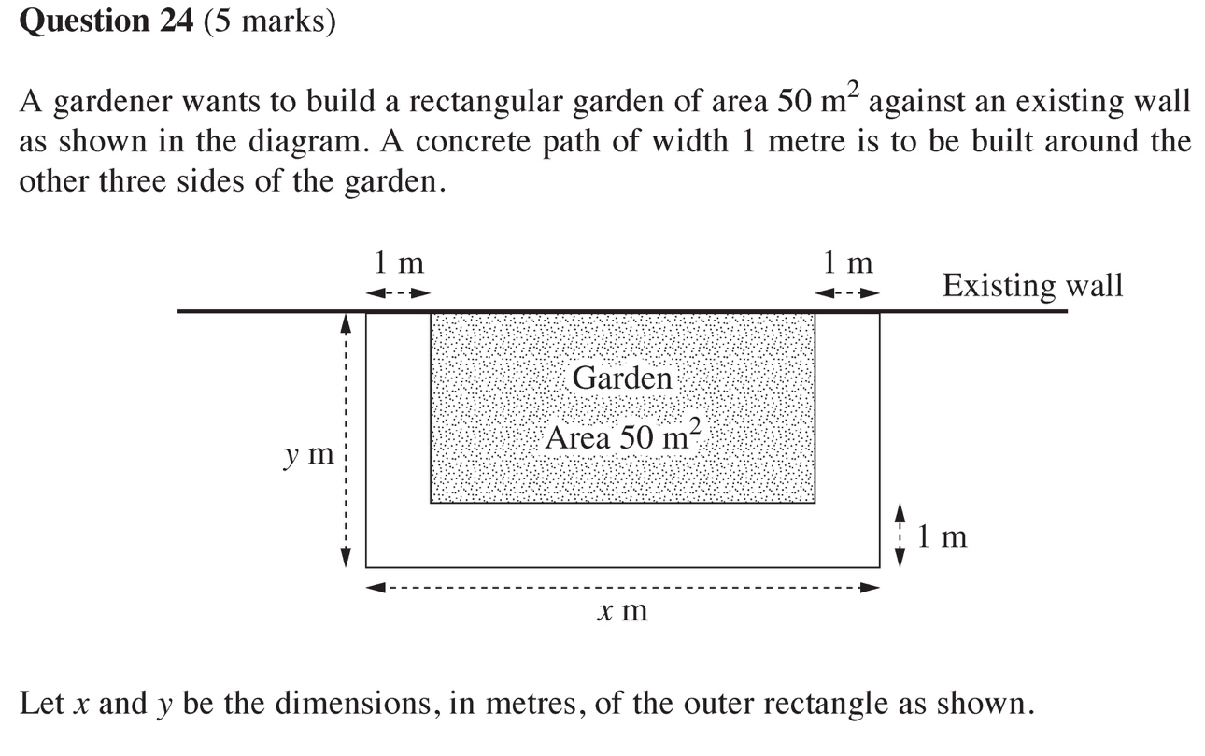

Figure 2a. Word problem in a final year secondary school mathematics exam (NSW Education Standards Authority 2023a: 24-25)
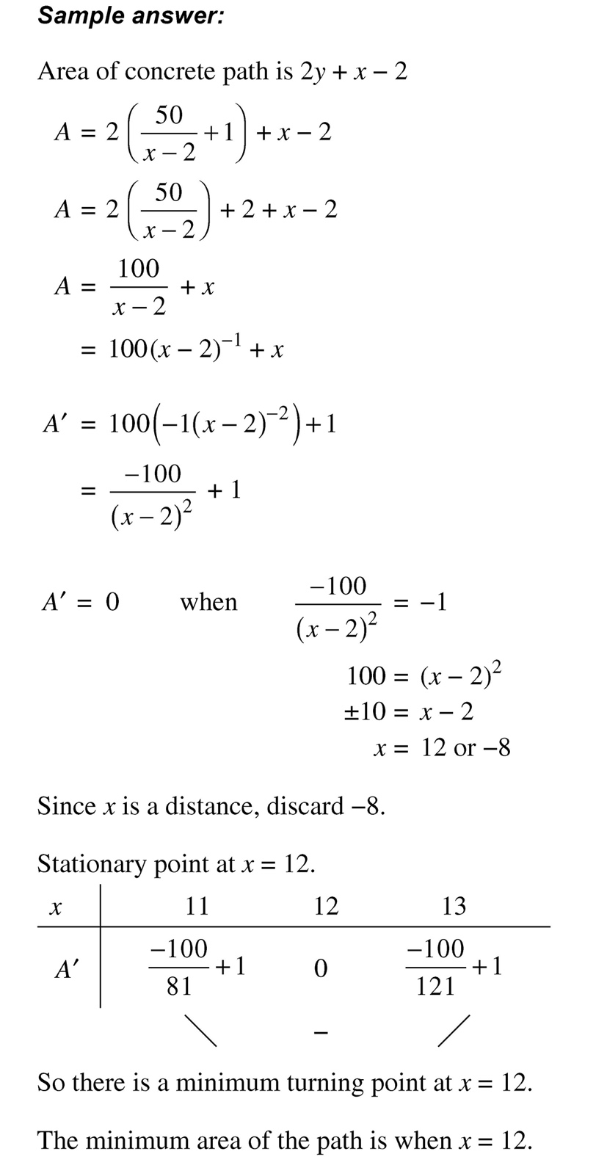

Figure 2b. Model solution to word problem in Figure 2a (NSW Education Standards Authority 2023b: 17)

Many students thus need support to read these word problems, interpret the key information and disregard the extraneous information. Rose (2021) suggests a three-step focus for scaffolding the reading of word problems, paralleling a similar proposal by de Oliveira (2012). The first step involves supporting students to identify the relevant data specified explicitly in the question; the second involves supporting students to infer further information or values needed for the solution that are not made explicit from the text and image in the question; and the third is to choose the mathematical process needed to solve this question.

3.2 Spoken language in mathematics education

Although the density of written language is typically considered the language of mathematics, as Veel (1999) notes, the vast majority of language in mathematics education is in fact spoken language from the teacher explaining or describing visuals and symbols written on the board. As O’Halloran (2000: 370) shows, with constant movement between language, symbols and images when modelling problems in the classroom, “spoken discourse is indispensable for contextualising the [mathematical] actions that are performed”. Veel (1999) suggests that there are two main features of spoken language in mathematics classrooms. The first is the overwhelming predominance of monologic teacher-talk about mathematical concepts and problems, taking the place of explanations that in other subjects would often be done through textbooks, slides or videos. The second is that when there is teacher-student dialogue, it tends to take a very standardised IRF (Initiation-Response-Feedback) sequence (Sinclair and Coulthard 1975), where the teacher asks a relatively closed question regarding something happening on the board (Initiation), a student responds with a short answer (Response) and the teacher evaluates this response as right or wrong (Evaluation), as illustrated in Veel’s (1999: 190) example:

Initiation | Teacher: | If I have something multiplied together, what do I do to get rid of it?
Response | Student: | Divide.
Feedback | Teacher: | Divide.
Rose (2021) argues that this standardised teacher-talk in mathematics raises a number of issues. First, if the procedure of how to solve a mathematical problem is given in spoken language, then it is lost at the moment of speaking. Although the board shows the symbolic text which persists after its explanation, the procedure about how to do the symbolic text does not remain. Any students who did not entirely follow what the teacher was saying in the first instance (i.e. a significant proportion, if not the majority in most classes) thus have minimal recourse but to ask the teacher again. Among other things, this maintains the inequitable success that underpins mathematics classrooms whereby some students can follow the teacher and thus succeed in the class, while others become lost and experience a lack of success and potentially withdrawal from mathematics. Rose (2021: 261) also argues that this purely oral explanation likely accounts for why much class-time in mathematics is taken up by student practice that requires the teacher walking around the room and having to repeatedly re-explain to individual students how to do the problems they are facing. The students who have followed the teacher thus likely gain the most benefit from this individualised practice, whereas the students who did not follow the teacher initially gain the least as they need to wait for the teacher to come around and re-explain the task.

In response, Rose (2021) proposes a pedagogy based on the Reading to Learn Program that aims to make explicit the process of doing mathematical problems so that all students can engage. The first step involves modelled practice, similar to what is described above, where the teacher models how to solve a problem on the board and speaks through the procedure. After reading the problem with the class, the teacher asks students to identify key information in the problem, which is then written on the board, before modelling how to solve the problem. Under Rose’s proposal, when the teacher is modelling how to solve the problem, rather than only saying the procedure orally, they also name each step and write it on the board for the students to refer to later on. An example of these steps for a trigonometry class is shown in Figure 3 (Rose 2021: 262).

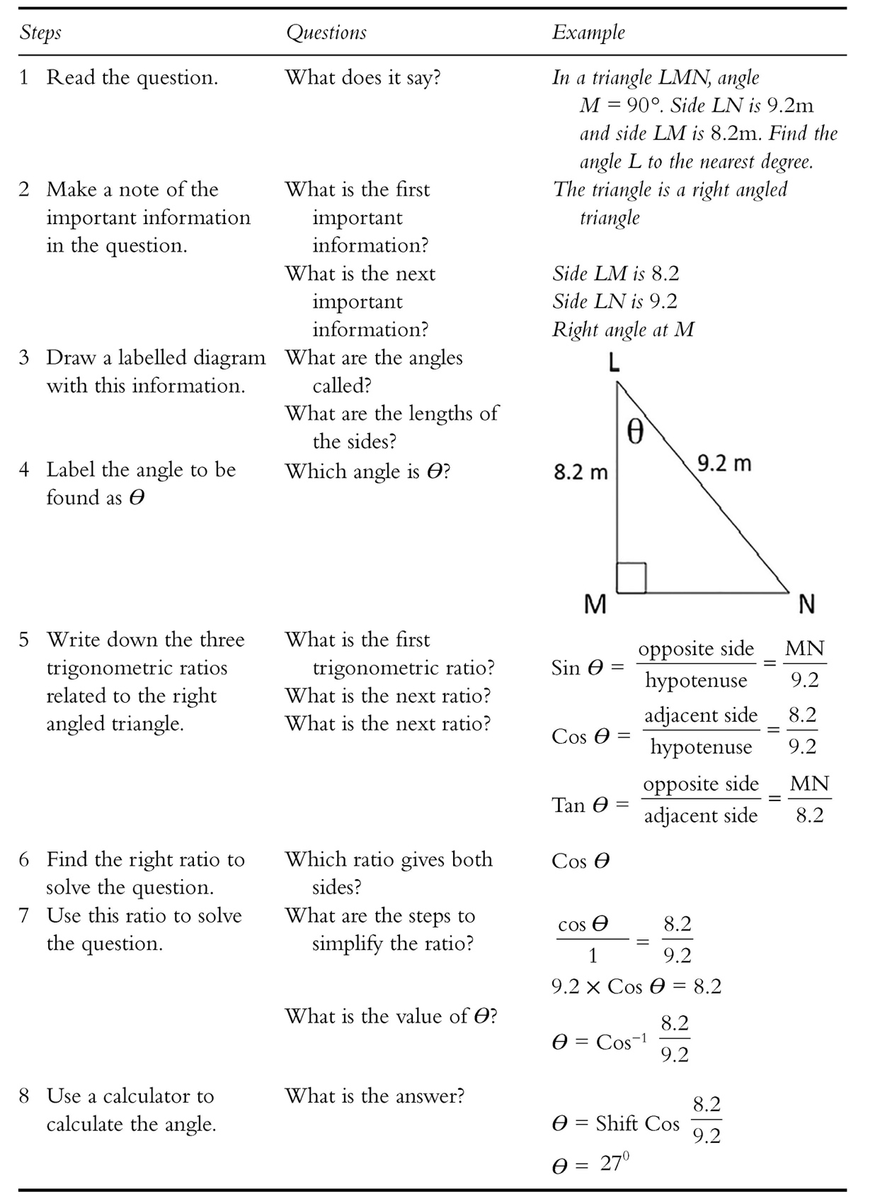
Figure 3. Written procedure and worked example used for teacher modelling of mathematical processes from Rose (2021: 262).

Following the modelling, the second step involves guided practice. Here, a new problem is written on the board and worked through in relation to the written steps on the board. A different student is asked to read out each new step and come up to the board to complete it, with guidance from the teacher and other students. During this step, students are given considerable scaffolding to support their first attempt at solving this new type of mathematics problem. A second guided practice can then be done using a new problem and following the same sequence. At this stage, the teacher works to involve as many students as possible to collectively solve the problem, especially focusing on reluctant or struggling students. Because the steps have been modelled twice and are still written on the board, students are much more likely to be able to succeed in solving each step of the problem at this stage. The final stage in Rose’s suggested teaching sequence involves a joint construction of the procedure for solving the problem itself. This involves students taking turns to write each step on the board, with the class telling the scribe what to write and with guidance from the teacher. Students then keep a copy of the procedure to support their independent practice.

The overarching goal of this pedagogy is to make explicit the ways of doing mathematics that allow for maximum guidance to students. Importantly for our purposes in this chapter, it does this through an explicit engagement with the multimodal discourse of mathematics and the differing roles of spoken language, written language and mathematical symbolism.

- Mathematical symbolism

Learning how to do mathematics of course involves not just language but mathematical symbolism itself. As noted above, mathematical symbolism is not confined to the subject of mathematics but occurs across a wide range of subject areas. One of the reasons for its wide use in technical fields is its ability to describe complex interdependencies between variables (O’Halloran 2005: 105). This is illustrated by the formula for momentum we saw above:

$$p=mv$$

This formula presents an interdependency relationship between p (momentum), m (mass) and v (velocity) whereby a variation in any symbol leads to variation in at least one of the others. This contrasts with language where causation, or more generally what Martin (1992) calls implication, tends to be uni-directional, with a cause being construed as leading to an effect, rather than there being a mutual interdependency where changes in each cause changes in the others.

There can be indefinitely many symbols in a mathematical equation, meaning that a large number of interdependent relations can be established at once. This is illustrated in the following equation from a final year secondary school physics exam. This equation brings together seven variables (plus three numerals and a constant) to describe the total energy that occurs when an object moves through a gravitational field set up by a larger body (e.g. when someone is falling to the ground on earth). The equation describes the sum of the kinetic energy arising from movement, K, and the gravitational potential energy arising from position in the gravitational field, U, in terms of the mass of the object and the larger body (m & M), the object’s velocity (v) and its distance from the centre of the body (r):

$$K+U=\frac{1}{2}mv^{2}-\frac{GMm}{r}$$
Mathematics thus allows for a wide range of technical meanings to be brought together in one efficient snapshot. As noted above, in terms of the Systemic Functional Linguistic concept of field (Doran and Martin 2021), mathematical symbolism realises interdependencies between properties. Properties are types of meaning that can be graded as more or less and ultimately gauged numerically. For example, in the equation above, m (mass) can be higher or lower in relation to the other symbols, and can be quantified, for example as 10 kg.

Mathematics’ focus on properties and their interrelations and quantifications underpins two broad mathematical genres in schooling. These two genres are known as quantifications and derivations (Doran 2018). Quantifications aim to produce a numerical result as either a measurement or prediction. This is illustrated by Text 3, an example from a Year 10 science textbook (Lofts & Evergreen 2023: 549) that aims to calculate the deceleration of a truck. In this text, we have marked the stages of the quantification on the left.

Situation | A truck is travelling at 35 m/s forwards (or +35 m/s) at the bottom of a hill but 10 seconds later at the top of the hill it has a velocity of 15 m/s forwards (or + 15 m/s). The truck has an acceleration of:  $$average acceleration=\frac{change in velocity}{time taken} \\ =\frac{final velocity -initial velocity}{time taken}$$
Substitution | $$=\frac{15-35}{10}$$  $$=\frac{- 20}{10}$$
Numerical Result | $$=-2.0 m/s^{2}$$
Interpretation | That is, on average, the truck decreases its velocity by 2 m/s each second, because its acceleration is in the opposite direction to its velocity.

Text 3. A quantification in a Year 10 science textbook (Lofts & Evergreen 2023: 549)

Quantifications typically open with a Situation stage usually involving both language and mathematics. The Situation tends to specify the setting of the problem and the starting numerical quantities needed for the calculation. In this case, it specifies two velocities (+35 m/s and +15 m/s), and the time between them (10 seconds). Situations also often specify the formula needed to do the calculation – in this case: $average acceleration=\frac{change in velocity}{time taken}$ and its rearrangement $(average acceleration=\frac{final velocity-initial velocity}{time taken})$.

The following Substitution stage involves inserting the numbers from the Situation into the starting equation. In this case, it inserts the two velocities +15 m/s and + 35 m/s as the final and initial velocity respectively, and the time given in the Situation as the time taken, to produce $=\frac{15-35}{10}$ which is then simplified to $=-\frac{20}{10}$ .

The Numerical Result is in some sense the core of the quantification, giving its final goal developed through the previous calculations: in this case $\left(average acceleration\right)= -2.0 m/s^{2}$. The Result is often then followed by an Interpretation of the result in language. This is particularly the case when mathematics is used in subjects such as the sciences, where the manipulation of mathematics itself is not the goal but is rather used in service of solving a physical, chemical or biological problem. Quantifications thus allow disciplines to bridge between abstract technical theory and empirical description (Doran 2017, 2021). In the case of Text 3, this text arises in a section explaining that in physics, deceleration is better described as negative acceleration, and so the Interpretation reflects this by interpreting the minus sign in the result as the acceleration being in the opposite direction of the velocity.

Although language is regularly used in quantifications, it is not always required. This is especially so when the calculations themselves are the end goal, such as for assessment questions asking for a numerical result. Text 4, for example, shows a relatively minimal quantification genre used as a sample answer in a mathematics exam (NESA 2023b: 6). This answer comes after a table of values giving different interest rates and time periods, and responds to the following question:

Mickey wants to save $450 000 over the next 10 years.

If the interest rate is 6% per annum compounding annually, how much should Mickey contribute each year? Give you answer to the nearest dollar.

The sample response, with genre stages included, is:

Substitution | $$Amount=\frac{\$450 000}{13.181}$$
Numerical Result | $$=\$34 140$$

Text 4. A minimal quantification as a sample answer to a mathematics exam question (NESA 2023b: 6)

In this case, all the details have been given in the question and the preceding table of values (not shown here), and so there is no need for a separate Situation. Similarly, the question asks for a numerical result rather than any interpretation of it and so there is no need for an Interpretation stage. It nonetheless conforms to a relatively minimal quantification genre in having both a Substitution and a Numerical Result.

Derivations focus on building new symbolic results (Doran 2018). This involves taking previously known relationships, as realised through equations, and manipulating these equations to produce a new equation or set of relations. This may either be a brand-new result for the text or student; or it may be as a ‘proof’, where a relation is put forward, and then needs to be derived from another relation to ‘prove’ it is correct. Unlike quantifications, derivations are less focused on predicting or measuring the empirical world but rather on developing new technical meanings in the field (Doran 2017, 2021). Text 5 shows an example of a derivation from a final year high school physics textbook (Marsden 2003: 14), developing a new equation for understanding how the wavelength of light is related to its momentum. We have again labelled the stages of the derivation genre here.

Situation | Einstein’s particle mathematics when applied to photons was powerful in its implications:  $E_{photon}=mc^{2}$…….. Einstein  $E_{photon}=hf$………. Planck  $=hc/λ$ as $c=fλ$
Rearrangement | Equating them $mc^{2}=\frac{hc}{λ}$  $mc=h/λ$
Symbolic Result | $λ=h/mc$
Interpretation | The quantity mc is the photon momentum (mass x velocity).

Text 5. A short derivation in physics (Marsden 2003: 14)

Like quantifications, derivations typically begin with a Situation describing the context of the derivation and any starting equations. In this case, this text comes at a section of the textbook introducing the particle interpretation of light within quantum mechanics, associated with Einstein and Planck. For this reason the text begins with known equations previously introduced in the textbook: Einstein’s famous $E=mc^{2}$, where E stands for Energy, m is mass and c is the speed of light; Planck’s proposal for the relationship between energy and the frequency of an object $E=hf$, where E is energy, h is Planck’s constant (6.626 x 10⁻³⁴) and f is frequency; and a well-known relation linking the speed of light (c) with its wavelength (λ) and frequency (f). Because this text is not concerned with measuring something or predicting its precise numerical value, the Situation does not specify any starting numbers – derivations typically remain in the pronumerical (symbols such as m, E, h, $λ$) rather than the numerical.
Following the Situation, the Rearrangement stage focuses on manipulating the starting equations to move toward the final result. In this instance, there are only two steps in the Rearrangement: equating mc² with hc/λ as they are both equal to E, and then rearranging these to produce $mc=h/$λ. But as Lopez (2024) shows, the Rearrangement stage can be significantly expanded with a much larger number of steps. The Rearrangement or its counterpart in quantifications, the Substitution, are often what is referred to in mathematics education as one’s working. This is because they make explicit the logical sequence of steps needed to move from the initial equations to the final result. Indeed, if the derivation is a proof, where the end result is given at the beginning and then needs to be shown to be correct, the Rearrangement, in fact, becomes the core of the text as this is what shows that the final result holds.

As with quantifications, the Symbolic Result provides the end goal of the text. In Text 5, this is given by the final equation $λ=h/mc$, which is found through a rearrangement of the previous equation. And like in quantifications, the end result is often followed by an Interpretation stage, where the result is interpreted in language.

The genres we’ve seen so far have been relatively short. Derivations and quantifications are what Martin (1994) calls elemental genres – relatively short, self-contained genres that unfold through a relatively definite sequence of stages. But mathematical texts of course regularly get significantly bigger and more complex. This typically happens through the complexing of multiple genres into one text. An example of this is shown in Text 6, a reproduction of the final year secondary school mathematics exam model solution given in Figure 2 above, that complexes two derivations with a quantification. The complex of genres arises because this text aims to find the length of a path at the bottom of a garden (x) that would give the minimum area for the path, but first requires the student needs to derive a new equation. In this text, many of the initial values and formulas given in the first derivation come from interpreting the diagram given in Figure 2.

derivation | Situation | Area of concrete path is $2y+x-2$
derivation | Rearrangement | $$A=2\left(\frac{50}{x-2}\right)+x-2 \\ A=2\left(\frac{50}{x-2}\right)+2+x-2 \\ A=\frac{100}{x-2}+x$$
derivation | Symbolic Result | $$=100{\left(x-2\right)}^{-1}+x$$
derivation | Rearrangement | $$A^{'}=100\left(-1{\left(x-2\right)}^{-2}\right)+1$$
derivation | Symbolic Result | $$=-\frac{100}{{\left(x-2\right)}^{2}}+1$$
quantification | Situation | $A^{'}=0$ when $-\frac{100}{{\left(x-2\right)}^{2}}=-1$
quantification | Substitution | $$100={\left(x-2\right)}^{2} \\ ±10=x-2$$
quantification | Numerical Result | $$x=12 or-8$$
quantification | Interpretation | Since x is a distance, discard -8.  Stationary point at $x=12$  So there is a minimum turning point at $x=12$  The minimum area of the path is when $x=12$
  $$x$$ | $$11$$ | $$12$$ | $$13$$
  $$A'$$ | $$-\frac{100}{81}+1$$ | $$0$$ | $$-\frac{100}{121}+1$$
   |  | –

Text 6. A longer mathematical text complexing two derivations and a quantification
(NSW Education Standards Authority 2023b: 17)

The first derivation focuses on developing a formula for the area of the path A that is entirely dependent on the variable that the student needs to quantify, x, rather than being dependent on multiple variables (x and y). It begins by stating a relationship that the Area of concrete path is $2y+x-2$ which can be found by interpreting the diagram (in Figure 2) This functions as the starting Situation in the opening derivation. The rest of the first derivation then focuses on manipulating this relationship to producee the final Symbolic Result where the Area is given purely in terms of x: $\left(A\right)=100{\left(x-2\right)}^{-1}+x$. The second derivation involves taking the derivative of this Symbolic Result, and then manipulating it to produce another Symbolic Result: $A^{'}=-\frac{100}{{\left(x-2\right)}^{2}}+1$.

From this formula, students can do the calculation needed and so can turn to a quantification. The Situation specifies that the relevant value for $A^{'}$ is 0 (known as the ‘stationary point’), and so this is substituted into the formula developed in the previous derivation, producing the final Numerical Result. In this instance, there are in fact two possible results: $x=12$ and $x=-8$. The Interpretation stage is then used to determine which one is relevant by noting that x is a distance. As distances cannot be negative (i.e. something cannot be -8m long), the positive number $x=12$ is chosen and is interpreted as the stationary point and minimum turning point, both through language and through the table in the Interpretation. This minimum turning point is then reinterpreted in terms of the wording of the question: that The minimum area of the path is when $x=12$.

This text illustrates how mathematical genres can be complexed together to build larger texts. Indeed, at higher levels of mathematics and science, it is rarely the case that elemental genres pose trouble for students. Rather, it is the choice of different genres, their sequencing and the relations between them that pose the greatest challenge. Put another way, the challenge students face is often what they need to do to solve the problem, it is not the construction of any particular quantification or derivation itself. Although we will not explore it here, Doran (2018) provides a generalised description of the types of relation that can hold between mathematical genres in texts such as this, building on the logico-semantic relations of Halliday (e.g. Halliday and Matthiessen 2014).

The complexing of distinct genres to make larger texts reflects a broader motif of iteration within mathematics (O’Halloran 2005). Lopez (2024) shows that indefinite numbers of equations can be sequenced together in any given genre stage, and we have already seen that there can be an indefinite number of symbols within an equation:

$$K+U=\frac{1}{2}mv^{2}-\frac{GMm}{r}$$

This iteration also extends to expanding the number of expressions: i.e an indefinite number of ‘sides’ of the equation linked by equals signs or another relator. The following equation for example has four expressions:

$$λ=\frac{v}{f}=\frac{3×{10}^{8}}{104.1×{10}^{6}}=2.9m$$

Doran (2020) suggests that this motif of iteration gives an insight into the functionality of mathematics in relation to language. Whereas language is somewhat constrained in the ideational meaning it can build efficiently, due to it needing to keep hold of many other meanings at once (including interpersonal and textual meaning), mathematics is less constrained in this regard by focusing almost entirely on ideational meaning (O’Halloran 2005). Its ability to expand its various meanings indefinitely, whether that be within an equation or across a text, allows it to bring together an exceptionally large number of technical meanings into specific relationships in one snapshot. This is an immensely useful tool for technical disciplines that aim to build uncommon-sense understandings that relate a wide range of meanings. Indeed, by showing similarities in this regard between mathematical symbolism, nuclear equations in physics, and tree diagrams and system networks in linguistics, Doran (2020) suggests that this motif of iteration could underpin academic formalisms in general. This is supported by work on chemical formalisms by Yu (e.g. 2021; Yu and Doran 2024), who showed that chemical formulas, chemical equations and structural formulas all show similar patterns of iteration.

Nonetheless, as we have seen throughout this chapter, despite the particular functionality of mathematics, it works closely with language to build its meanings. As a final illustration of this point, we can look at how mathematics seamlessly integrates with language in building a coherent flow of information. As with English, mathematics displays a distinct thematic pattern, where the initial expression functions as Theme (O’Halloran 2005).

$$W_{earth}$$ | $$=mg_{earth}$$
Theme

Also as in language-only texts, the Theme in mathematics is typically relatively predictable, and holds an angle on the field that is then elaborated in the right-hand expression. This is most clearly seen when the Theme is in fact elided in subsequent equations – a common occurrence in mathematical texts (example from de Jong et al. 1990: 249; as analysed in Doran 2018):

$$W_{earth}=mg_{earth} \\ =50×9.8 \\ =490 N downwards$$

By contrast the rest of the equation can be labelled the Rheme, following O’Halloran’s (2005) adaptation of Halliday’s grammar of English (Halliday and Matthiessen 2014). The final expression in any equation additionally realises a second point of informational prominence that, following Halliday’s description of English, we can call the New. Whereas the Theme holds a relatively stable angle from which we are viewing the equation, the New provides the informationally prominent ‘point’. The New is particularly prominent when there are more than the default two expressions in an equation. In instances such as this, the intervening expressions are informationally backgrounded and the final expression is made particularly prominent – often so as to highlight the final result of a quantification or derivation. In the following equation for example, the final expression that is highlighted as a particularly prominent New gives the final answer to a question posed earlier in the text, and so is in some sense the primary result of the text:

$$Loss of weight$$ | $$=490-180$$ | $$=310 N$$
Theme | Rheme
 |  | New

The interaction of mathematics’ Theme and New patterns works closely with that of language. This can be seen if we look at the whole text that the above equations come from. For this text, I have bolded the mathematical Themes and have highlighted in grey the mathematical News.

Calculate how much weight a 50kg girl would lose if she migrated from the earth to a colony on the surface of Mars.

On the earth:  $$W_{earth}=mg_{earth} \\ =50×9.8 \\ =490 N downwards$$ | On Mars:  $$W_{Mars}=mg_{Mars} \\ =50×3.6 \\ =180 N downwards$$

Loss of weight = 490 – 180 = 310 N. But there is no loss of mass!

Text 8. From de Jong et al. (1990:249)

Looking first at the text’s thematic patterning, each Theme picks up information that was provided earlier in the text. In the case of W_{earth} and W_{Mars} standing for the weight of the earth and weight of Mars respectively, these highlight the centrality of the weight for the whole text, linking back its mention in the opening question. By repeating these themes through ellipsis, the text emphasises the continuity of these stretches within the overall text. The distinction between W_{earth} and W_{Mars} additionally reflects a distinction made in the question between Earth and Mars, that is picked up in the marked topical Themes (Halliday and Matthiessen 2014) for each stretch: On the earth and On Mars. Similarly, in the final equation, the Loss of weight as Theme nominalises the information that the question asks to be calculated: how much weight a 50kg girl would lose. The mathematical Themes thus show the relevance of the equations at every step.

The News, on the other hand, show unfolding changes. In the case of the two stretches focusing on the W_{earth} and W_{Mars}, each New shows a change that realises shifts in stage in the quantification genre. For example:

$$W_{earth}$$ | $$=mg_{earth}$$ | Situation
 | $$=50×9.8$$ | Substitution
 | $$=490 N downwards$$ | Numerical Result

Similarly, as we have already seen, the New of the final equation provides the final Numerical Result for the whole quantification complex. Thus, whereas the Thematic pattern of the mathematical text shows the stable angle from which we are viewing the text, the News highlight the prominent meanings that allow the text to unfold and develop.

While this may seem unremarkable to those who are fluent in reading and writing mathematics, this is only because of how strong this informational pattern is. Although it is possible, it would be very odd, for example, to see a text that swaps the ordering of expressions in this regard, such as the following:

Calculate how much weight a 50kg girl would lose if she migrated from the earth to a colony on the surface of Mars.

On the earth:  $$mg_{earth}=W_{earth} \\ 50×9.8=W_{earth} \\ 490 N downwards=W_{earth}$$ | On Mars:  $$mg_{earth}=W_{Mars} \\ 50×3.6=W_{Mars} \\ 180 N downwards=W_{Mars}$$

310 N = 490 – 180 = Loss of weight. But there is no loss of mass!

This discussion of information flow illustrates the inherently multimodal nature of mathematics. Language, mathematical symbolism and other resources such as images work together to seamlessly build the technical meanings of whatever field they are being used in.

Mathematics and multimodal literacy

It is now commonly accepted in the field of literacy that students need support with reading and writing multimodal text. But when it comes to mathematical texts, mathematical symbolism is often considered too technical for it to be engaged with in detail by literacy researchers. At the same time, those working in mathematics and numeracy education rarely have the training and experience in literacy education to be able engage with the literacy issues that pervade mathematics in education. The result of this has been a significant separation between mathematics educators and literacy educators, with each rarely bringing their expertise to the other’s problems. But as examples such as Rose’s Reading to Learn pedagogy has shown, there is scope for literacy educators to engage with mathematics teaching. The major challenge, however, is to be able to bridge the gap between the technical understandings brought to mathematics by mathematics educators and the technical understandings brought to multimodal text by literacy educators, so as to develop a metalanguage and pedagogy that can speak both ways, and be accessible and useful to students.

In this chapter I have aimed to illustrate some possible avenues for building such a metalanguage and pedagogy; but there is much more to be done. For example the genre descriptions given above for mathematical texts would likely be considered overly simplistic for mathematics educators who require considerably more delicate understandings of the mathematical problems students need to solve. But they nonetheless offer a pathway for literacy educators to engage with mathematical texts and build clear understandings of the subtypes of problems that mathematics educators need. On the other hand, the technicality used by mathematics educators when discussing different problems may seem to literacy educators to be too far away from our understandings of text to be able to engage with. But importantly, unlike many disciplines that engage with text outside of linguistics and literacy, mathematics does not shy away from building technical language for their texts. That is, mathematics education is very comfortable with building a metalanguage for talking about mathematics. Though it will take time, these parallels offer avenues in which literacy educators and mathematics educators can engage, in order to learn and adapt each other’s metalanguage and pedagogies and enhance the teaching and learning of mathematical text.

References

Accurso, Kathryn, Meg Gebhard & Stephanie B. Purington. 2017. Analyzing Diverse Learners’ Writing in Mathematics: Systemic Functional Linguistics in Secondary Pre-Service Teacher Education. International Journal for Mathematics Teaching and Learning. 18.1. 84-108.
Chen, Lin. 2024. Knowledge-Building in Tertiary Medical Science: A Linguistic Exploration of Disciplinary Discourse and Pedagogic Practices Focusing on the MBBS (Bachelor of Medicine and Bachelor of Surgery) Program in China. Unpublished Doctoral Thesis, Department of Linguistics, The University of Sydney.
de Jong, Eddy, Fred Armitage, Mary Brown, Paul Butler & Jennie Hayes. 1990. Heinemann Physics in Context: Physics One: Energy in Everyday Life: Movement and Electricity. Melbourne: Heinemann Educational Australia.
de Oliveira, Luciana C. 2012. The language demands of word problems for English language learners. In Sylvia Celedón & Nora G. Ramirez (eds) Beyond Good Teaching: Advancing Mathematics Education for ELLs. Reston: National Council of Teachers of Mathematics. 195-205.
Doran, Y.J. 2017. The role of mathematics in physics: Building knowledge and describing the empirical world. Onomázein. Special Issue: Systemic Functional Linguistics and Legitimation Code Theory. 209-226.
Doran, Y.J. 2018. The Discourse of Physics: Building Knowledge through Language, Mathematics and Image. London: Routledge.
Doran, Y.J. 2020. Academic formalisms: Toward a semiotic typology. In J.R. Martin, Y.J. Doran & Giacomo Figueredo (eds) Systemic Functional Language Description: Making Meaning Matter. Routledge. 331-358.
Doran, Y.J. 2021. Multimodal knowledge: Language, mathematics and image in physics. In Karl Maton, J.R. Martin & Y.J. Doran (eds) Teaching Science: Knowledge, Language, Pedagogy. Routledge. 162-185.
Doran, Y.J. & Martin, J.R. 2021. Field relations: Understanding scientific explanations. In Karl Maton, J.R. Martin & Y.J. Doran (eds) Teaching Science: Knowledge, Language, Pedagogy. London: Routledge. 105-133.
Fomenko, Anatoly 1990. Visual Geometry and Topology. Berlin: Springer-Verlag.
Goos, Merrilyn, Vince Geiger, Shelley Dole, Helen Forgasz, & Anne Bennison 2019. Numeracy Across the Curriculum: Research-based Strategies for Enhancing Teaching and Learning. Sydney: Allen and Unwin.
Halliday, M.A.K. 1978. Sociolinguistic aspects of mathematical education. In Language as Social Semiotic. London: Edward Arnold. 194-204.
Halliday, M.A.K. 1989. Some grammatical problems in scientific English. Australian Review of Applied Linguistics. 5:6. 13027.
Halliday, M.A.K. 1998. Things and relations: Regrammaticising experience as technical knowledge. In J.R. Martin & R. Veel (eds). Reading Science: Critical and Functional Perspectives on the Discourse of Science. London: Routledge. 185-236,
Halliday, M.A.K. & Matthiessen, Christian M.I.M. 2014. Halliday’s Introduction to Functional Grammar. 4th ed. London: Routledge.
Lemke, Jay L. 1985. Mathematics in the Middle: Measure, Picture, Gesture, Sign and Word. In Myrdene Anderson, Adalira Saenz-Ludlow, Shea Zellweger and Victor V. Ciffarelli (eds.) Educational Perspectives on Mathematics as Semiosis: From thinking to Interpreting to Knowing. Ottawa: Lega. 215-234.
Lofts, Graeme & Merrin J. Evergreen 2023. Jacaranda Science Quest 10: Australia Curriculum. 4th Ed. Melbourne: John Wiley.
Lopez, Dany 2024. The Quality of Reports in Undergraduate Physics Laboratory Course and Their Relationship with the Level of Scientific Abilities. Unpublished PhD thesis, Pontificia Universidad Católica de Chile and Australia Catholic University.
Martin, J.R. 1992. English Text: System and Structure. Amsterdam: John Benjamins.
Martin, J.R. 1994. Modelling big texts; A systemic functional approach to multi-genericity.
Marsden, G.R. 2003. Timesavers Senior Physics: Quanta to Quarks. Peakhurst: Timesavers.
NSW Education Standards Authority (2023a) Mathematics Advanced: Higher School Certificate Examination Paper. NSW Education Standards Authority.
NSW Education Standards Authority (2023b) Higher School Certificate Mathematics Advanced Marking Guidelines. NSW Education Standards Authority.
O’Halloran, Kay L. 2000. Classroom discourse in mathematics: A multisemiotic analysis. Linguistics and Education. 10:3. 359-388,
O’Halloran, Kay L. 2005. Mathematical Discourse: Language, Symbolism and Visual Images. London: Continuum.
O’Halloran, Kay L. 2015. The language of learning mathematics: A multimodal perspective. The Journal of Mathematics Behaviour. 40. 63-74.
Rose, David 2020. Reading to Learn Teacher Resource Book 9: Planning for Success in Maths. Reading to Learn.
Rose, David 2021. Doing maths: (De)constructing procedures for maths processes. In Karl Maton, J.R. Martin & Y.J. Doran (eds) Teaching Science: Knowledge, Language, Pedagogy. London: Routledge. 257-286.
Rose, David & Martin, J.R. 2012. (eds) Learning to Write, Reading to Learn: Genre, Knowledge and Pedagogy in the Sydney School. London: Equinox.
Schleppegrell, Mary J. 2007. The linguistic challenges of mathematics teaching and learning: A research review. Reading & Writing Quarterly. 23:2. 139-159.
Sinclair, John & Coulthard, Malcolm 1975. Towards an Analysis of Discourse: The English Used by Teachers and Pupils. London: Oxford University Press.
Veel, Robert 1999. Language, knowledge and authority in school mathematics. In Frances Christie (ed.) Pedagogy and the Shaping of Consciousness. London: Continuum. 185-216.
Wignell, Peter, Martin, J.R. & Eggins, Suzanne 1989. The discourse of geography: Ordering and explaining the experiential world. Linguistics and Education. 1:4. 359-91.
Yu, Zhigang 2021. Knowledge-Building of Chemistry in Secondary School Chemistry Textbooks: A Multisemiotic Perspective. Unpublished PhD dissertation, School of Foreign Languages, Tongji University.
Yu, Zhigang & Doran, Y.J. 2024. Chemical formalisms: Toward a semiotic typology. Semiotica. 259. 31-59.

At the time of writing, videos illustrating this pedagogy can be found here: https://educationstandards.nsw.edu.au/wps/portal/nesa/k-10/learning-areas/mathematics/planning-for-success-in-secondary-mathematics
Although we won’t explain the mathematical processes here, we can note that the derivative – an operation within the realm of calculus – is needed because the student needs to find what is known as the ‘turning point’ of a curve; something that can only be done at this level through calculus. Needless to say, the procedure for doing the mathematics is typically not stepped through in written mathematical texts, only the symbolic output of this procedure. As noted above, if the procedure is made explicit it is typically done orally in class, and so a pedagogy such as Rose’s is needed to make the procedure itself explicit in writing.
Doran (2018) labelled each expression following the Theme an Articulation in order to emphasise some of the differences with the Rheme of English. The final Articulation was then described as having a particular prominence that is similar to the English New marked by intonation. In hindsight, this was perhaps emphasising difference a bit too much, and so I have followed O’Halloran’s (2005) analysis here. The key point to remember however is that, in written mathematics, there is no intonation and so the New is necessarily realised as the final expression. In addition, unlike in English where the systems of theme and information are relatively independent, allowing for something to be both Theme and New, this cannot occur in mathematics. The two functions are in the same system and are mutually exclusive. In mathematics, the difference between a marked and an unmarked New arises by virtue of whether there are only two expressions, in which case there is not a particular prominence on the final expression (i.e. it is an unmarked New), or whether there is more than one expression, in which case the final expression is particularly prominent (i.e. is a marked New), while the other expressions that are neither Theme nor New are informationally backgrounded (Doran 2018: 77-80).

